Welcome to Targeted Instruction –Study Skills
Mrs. Portley
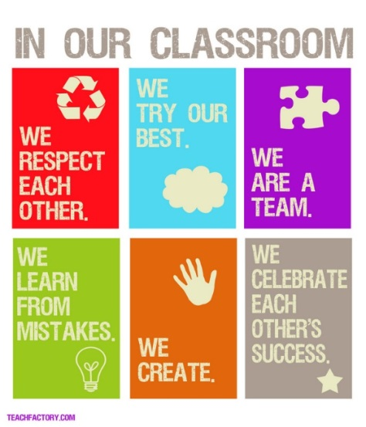
Targeted Instruction classes are designed to meet the specific needs of students with Individualized Education Programs at the high school level. The specific programming and curriculum for each student is determined by your IEP and input from you and your teachers regarding your personal strengths and challenges.

Structure:
Most of the time, you will be working on your assignments and using these assignments to target your study skill needs. There will, however, be times when we will be doing a group lesson or study skill exercise. During those times you will be required to participate. So remember, you cannot always plan to do your homework in Targeted Instruction. In order to complete your assignments in a timely manner, you will need to do some homework and studying at home. You cannot depend only on time in Targeted Instruction for this purpose. I will try my best to give advance notice so that you can plan accordingly. Below are a few important things to remember for Targeted Instruction.

Agendas:
You should record all assignments, tests, and projects in your agenda. You may use a device such as an iPad, laptop, or smartphone to record your assignments. However, be aware that I will check your agenda regularly, so you must bring it to class every day.

Organization and Preparation:
Part of being a responsible student is being prepared to learn. Have all necessary materials with you when you come to class, and please be sure to keep your backpack and school materials neat and orderly. I will periodically check-in to make sure you are ready for your classes.

Goal Monitoring:
You will become very familiar with your Individualized Education Plan (IEP). We work towards meeting your goals and objectives and will refer to this document often. You will also become familiar with any accommodations/modifications that will help you to be successful in all your classes. Your decisions and actions around your goals will help you to fill out a Targeted Instruction Rubric at the end of each class. We will be conferencing on a regular basis about your goals, your strategies for meeting these goals and what our next steps will be.
Work Samples:
I will periodically ask you and your content area teachers for samples of your work. Work samples need to be on file with your case managers for progress reporting. Please do NOT throw away important tests, quizzes, and writing assignments.

Grades/Progress:
Progress makes perfect! You will be asked to check your grades in PowerSchool on a weekly basis. You will record your progress each week and conference with me regarding your own unique goals.

Electronics:
You may use your personal devices in class for school-related activities, including research, word processing, and maintaining an agenda. You may not use your phone/device for music without permission. Videos and games are not permitted. I will have a safe place for you to store your phone in the classroom if you have difficulty refraining from using it inappropriately in class.

Grading:
Grading is individualized and based on your own goals and objectives. In addition, you will be graded on your overall organizational efforts, responsibility, on-task behavior and homework completion.

Grading will be as follows:
Targeted Instruction Rubric – 75%
(Includes Organization, On Task Behavior and work toward Goals)
Classwork -25%

I am looking forward to a great school year!!

