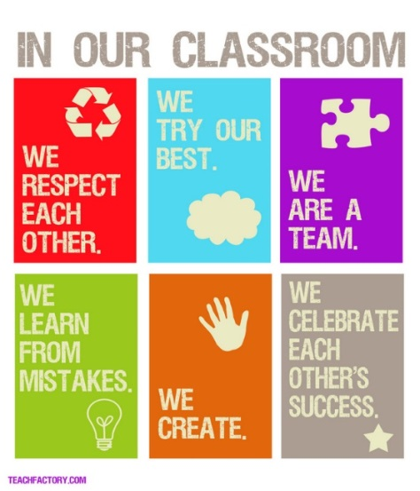
Welcome to Targeted Instruction for Writing! This class is designed to help you improve your writing skills. Together we will look at your current writing skills, identify the gaps in learning, and target those gaps for improvement. Writing is a lifelong skill and an important part of our everyday lives; whether we are writing for school, for work, or for fun, it is crucial to our success. By working together to capitalize on strengths and improve in areas that are more difficult, your skills and abilities as a writer will improve.

Structure:
Just like all your other classes, we will be meeting four times per week. Our time together will be divided as follows:

On Mondays and Fridays, our 45-minute classes, most of the time, you will have the opportunity to work on high priority assignments for your other classes. This will be your Study Skills time and can also be used for things like organizing your binders, studying for a test or quiz, getting help on an assignment you find difficult or writing practice.

On our 60-minute days, we will focus mainly on writing instruction, intervention, and practice. We will be learning and practicing writing skills and techniques that are essential for producing persuasive and informational writing pieces. Whenever possible, we will use writing assignments from your history, English, and science classes for intervention and practice. Your individual writing journals will also be used for writing practice.

1:1 Conferences and Instruction may be scheduled on any of the four days, but I will do my best to give you advance notice.

Remember, it will be important for you to plan ahead, so that you have the time that you need to get your work done in a timely manner. You will not be able to depend on time in TI-Writing to do all of your homework; you will also need to do homework at home.

Work Samples:
Please do NOT throw away writing assignments from your other classes. There is a folder in the file cabinet in my classroom for storing these items.

Grading:
Your grade for this class will be based on the following:

Classwork: 60%
Quizzes: 40%

I am looking forward to a great school year!!

